HOW TO REACH PALAZZO DELLA REGIONE VENETO
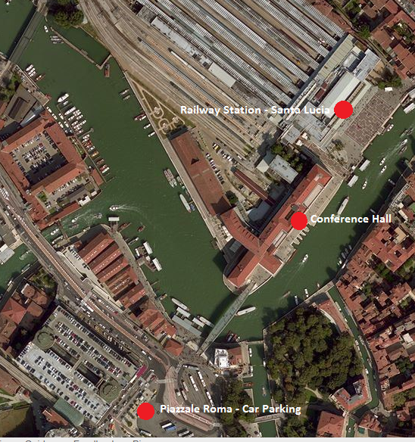

BY TRAIN
The Santa Lucia Railway Station is located near Palazzo della Regione Veneto: Exit the station, keep right and enter the main entrance of the Veneto Region Palace.
BY CAR
You can get to Venice by car through motorway (A4 from Trieste) and road links (highways SS.309 Romea from the Adriatic coast, SS.14 from Trieste, SS.13 from Treviso). Once you’ve reached the lagoon take the Ponte della Libertà, the bridge that literally links Venice to the mainland. If you follow the signs to Venice you’ll find yourself in Piazzale Roma, which is as far as you can go by car. Here you have to park your car.
In the Piazzale Roma area the following parking garages are available: Autorimessa Comunale, Garage S. Marco and S. Andrea. There is also a large parking lot on the Tronchetto island (turn right at the end of the bridge).
Once you are in Piazzale Roma, get off the bridge “Ponte della Costituzione", continue for about 100 meters, along the Palace of the Veneto Region, and enter the main entrance of the building.
However, another possible solution is to leave your car in Mestre (either in the parking lots by the entrance to the Ponte della Libertà or the ones near the Mestre railway station) and continue from there by train to Venice.

